**Algebra Concepts and Connections**

**Mrs. Sorrells**

**Course Syllabus 2023-2024**

**Course Description and Objectives**

This is the continuing course, in a sequence of courses, designed to provide students with a rigorous program of study in Mathematics. Students will understand various numerical representations, including integers; use and apply geometric properties of plane figures, including congruence and the similarity; use symbolic algebra to represent situations and solve problems, especially those that involve linear relationships; solve linear equations, systems of linear equations; use equations, tables and graphs to analyze and interpret linear functions; use and understand set theory and simple counting techniques; and make inferences from statistical data, particularly data that can be modeled by linear tables and graphs.

**Textbook**

Into Math Algebra 1 – Houghton Mifflin Harcourt

**Unit/Concept Names**

Unit 1 Modeling Linear Functions

Unit 2 Analyzing Linear Inequalities

Unit 3 Investigating Rational and Irrational Numbers

Unit 4 Modeling and Analyzing Quadratic Functions

Unit 5 Modeling and Analyzing Exponential Expressions and Equations

Unit 6 Analyzing Exponential Functions

Unit 7 Investigating Data

Unit 8 Algebraic Connections to Geometry Concepts

**Major Course Projects and Instructional Activities**

At least one project/task will be assigned for each Unit. This will be an extension or enrichment of the concepts discussed. Students will have 2-3 days to complete each project/task depending on the complexity of the task. Some tasks and/or projects will be completed in class (specifically the unit culminating tasks – these MUST be completed in class only).

**Course Assessment Plan**

Students will receive a variety of assignments designed to enhance their learning. If a student is absent, the student is responsible for the missed assignment. Students who have an excused absence will be allowed (teacher’s discretion) days to turn in the missed assignment. Late work accepted at teacher’s discretion.

**Evaluation (Grading Policy)**

* Major Grades 40% (Unit & Chapter Test, Projects, Tasks)
* Minor Grades 60% (Quizzes, Class work, Graded Writing Assignments, Group Work, etc.)

**Classroom Procedures & Expectations**

The overarching expectation in this class is to represent WAR (W, Accountable, Respectful)

Below are the expectations for how to W.A.R. in _____________ class!

1. Always Try YOUR BEST!!! I will not settle for anything but your best!!
2. Have the “I can do it” attitude! Stick To It and Don’t Give Up!
3. Remain SEATED and PREPARED at all times. Cellular Devices put away…
4. Bring ALL materials to class DAILY.
5. Every student is responsible for helping to maintain a clean, safe learning environment. Your area must remain CLEAN at all times. The floor should be clear of trash, paper, and personal belongings.
6. Adhere to all policies, rules, and regulations outlined in the student handbook, and RCSS Code of Conduct.

**Course Materials**

* 1-3 inch 3-ring Binder

* Pencils (mechanical pencils preferred)

* Handheld pencil sharpener * Highlighters

* Loose Leaf Paper * (2) two pocket plastic folders

* Coloring Utensils (crayons, coloring pencil, or markers)

**My contact information:**

Email: Sorrema@boe.richmond.k12.ga.us

**Resources:**

[www.desmos.com](http://www.desmos.com)

www.khanacademy.com

To sign up for class reminders, please visit:

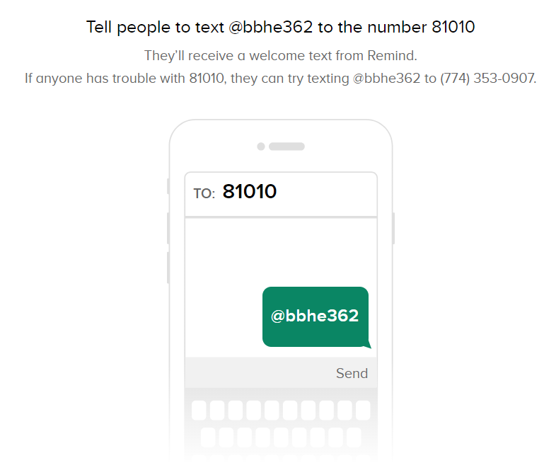 **5th Period algebra 1 6th Period algebra 1**

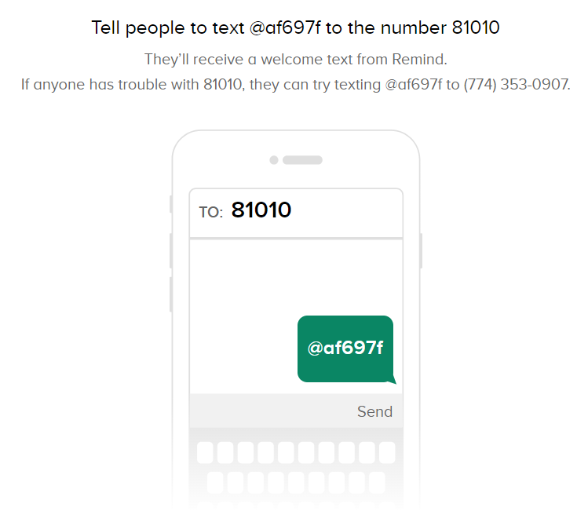

----------------------------------------------------------------------------------------------------------------------------------------------------------------

**Algebra Syllabus Parent Signature Form**

Please detach and return to Mrs. Sorrells

Student: (please print) ____________________________________(signature)________________________________

Parent: (please print) ____________________________________ (signature) ________________________________

Contact Information:____________________________(day phone)______________________________(evening phone)

Email: _____________________________________________________________________(I prefer this form of contact)